|  |  |
| --- | --- |
| Assignment 4  ITRI 623 | ENRICO DREYER  31210783 |

Table of Contents

Introduction 2

References in the poster 2

Reference List 2

# Introduction

For this assignment we were asked to make a poster on MongoDB’s data storage architecture and how data is stored in MongoDB. There should be references to Mongos/ Shards and all the technical things surrounding it. Referring to the image bellow, people without an understanding of IT should understand how data fits in the architecture of MongoDB.

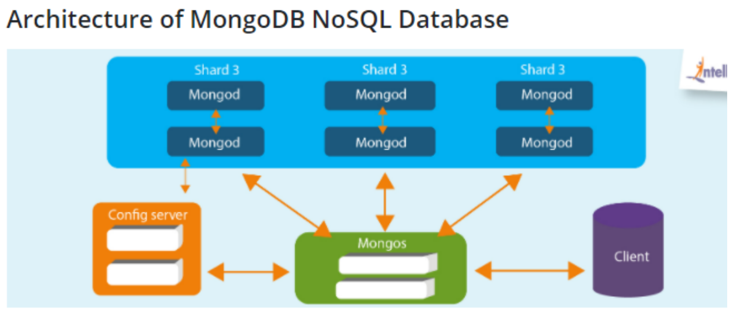

The poster will be attached in the same zip file as this document in png and pdf format.

# References in the poster

1. What is MongoDB? (IntelliPaat, 2021)
2. What is MongoDB Atlas? (Kirjanov, 2021)
3. What About Rows And Columns? (IntelliPaat, 2021)
4. The Data Model Used (CloudDuggu, 2020)
5. Why use MongoDB (Schaefer, 2020)
6. Advantages of using MongoDB (IntelliPaat, 2021)
7. Example of document in MongoDB (IntelliPaat, 2021)
8. Mongos/Shards (Pedamkar, 2021)
9. MongoDB Architecture (IntelliPaat, 2021)
10. Important MongoDB Facts (IntelliPaat, 2021)

# Reference List

CloudDuggu. (2020). MongoDB Interview Questions. <https://www.cloudduggu.com/mongodb/interview_questions/#:~:text=The%20data%20model%20used%20by%20MongoDB%20is%20based,the%20data%20at%20any%20level%20of%20Document%20nesting>.

IntelliPaat. (2021). What is MongoDB? <https://intellipaat.com/blog/what-is-mongodb/#:~:text=MongoDB%20Cloud%20is%20a%20unified%20data%20platform%20that,architecture%20that%20is%20built%20on%20collections%20and%20documents>.

Kirjanov, S. (2021). MongoDB vs MongoDB Atlas. <https://stackshare.io/stackups/mongodb-vs-mongodb-atlas#:~:text=MongoDB%20stores%20data%20in%20JSON-like%20documents%20that%20can,built%20and%20run%20by%20the%20team%20behind%20MongoDB>.

Pedamkar, P. (2021). MongoDB Sharding. <https://www.educba.com/mongodb-sharding/>

Schaefer, L. (2020). The Top 4 Reasons Why You Should Use MongoDB. <https://www.mongodb.com/developer/article/top-4-reasons-to-use-mongodb/>